Lab 2

HashTable-based implementation

Lung Alin-Sebastian

Gr. 934

Github Repository: <https://github.com/IcerOut/FLCD>

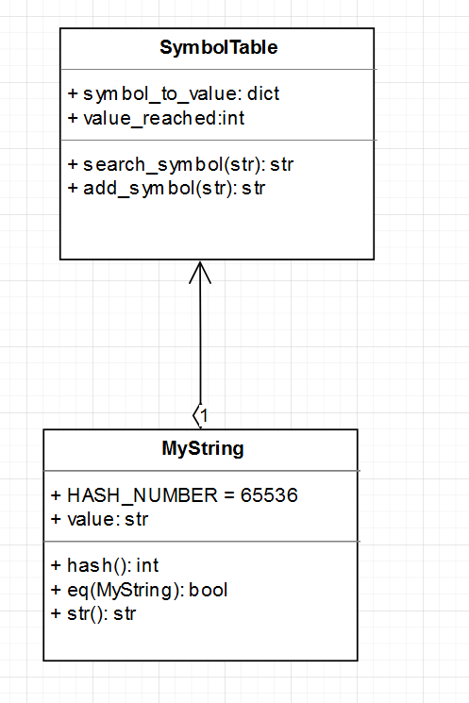

UML Diagram

The function “search_symbol” takes in the symbol and returns the value associated to it or “-1” if the symbol doesn’t appear in the SymbolTable.

The function “add_symbol” takes in the symbol and, if it already exists, returns its associated value. If it does not, it adds it to the hashtable and returns its newly associates value.

The implementation uses, internally, a Python dict object. It has a complexity for search and add of O(1)

Python’s dict uses the __hash__() method of whichever object it hashes. MyString’s hash function uses the sum of ASCII values % 65536 as the hash value.  
In case of hash collisions, Python’s dict uses open addressing using probing. Initially it has 8 free position and it gets resized when it reaches 2/3 of its maximum capacity